Electromagnetic Field and Power Flow Analysis of a
Rectangular Waveguide in CST Studio Suite and determination of S parameters.
Test Case 1:
To simulate a Rectangular Waveguide using CST Studio Suite, analyze its electromagnetic behaviour, and examine the power distribution among ports over a specified frequency range.
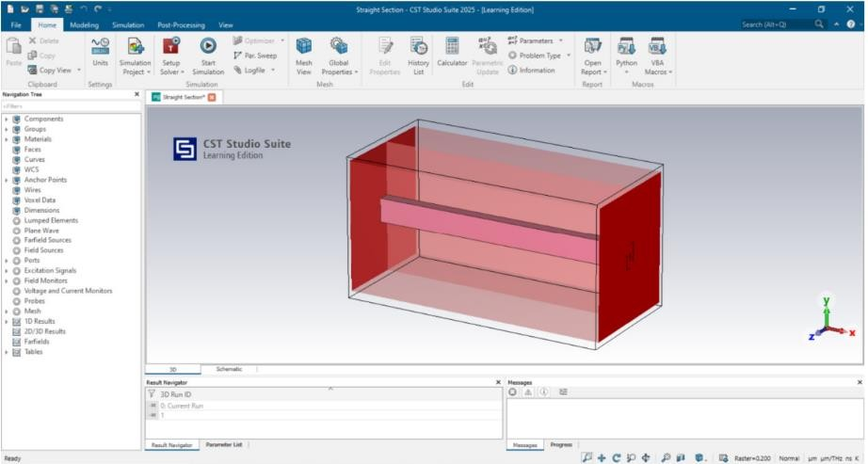
c
Output:
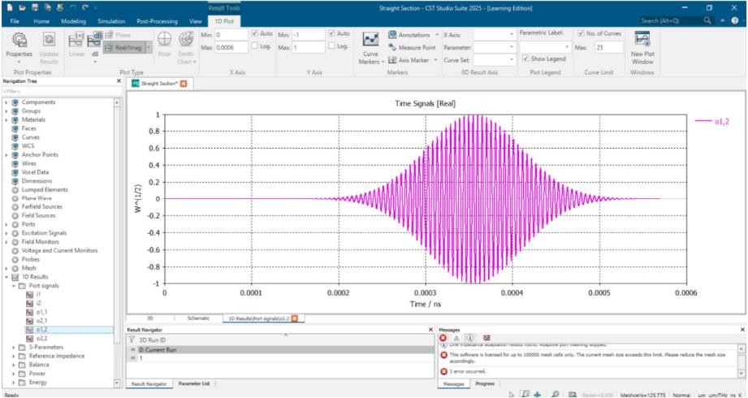
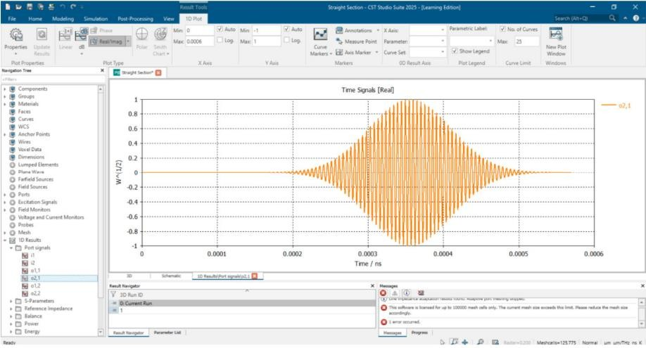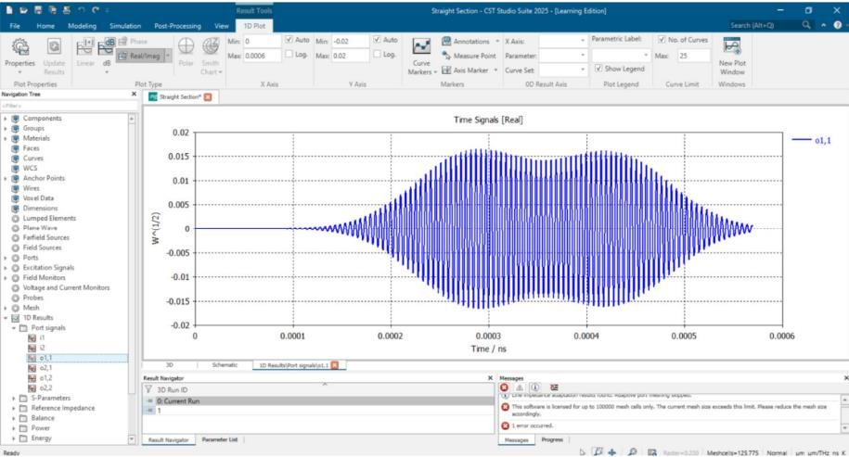
Test Case 2:
To simulate a Rectangular Waveguide using CST Studio Suite, analyze its electromagnetic behaviour, and examine the S parameters.

Output: 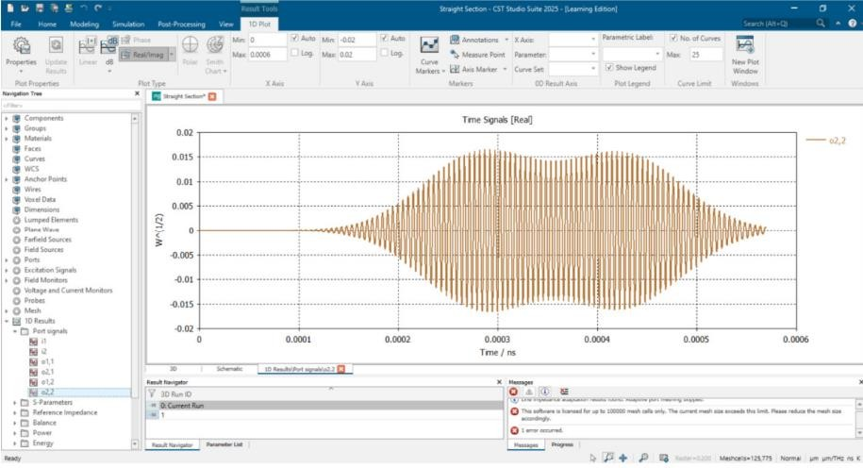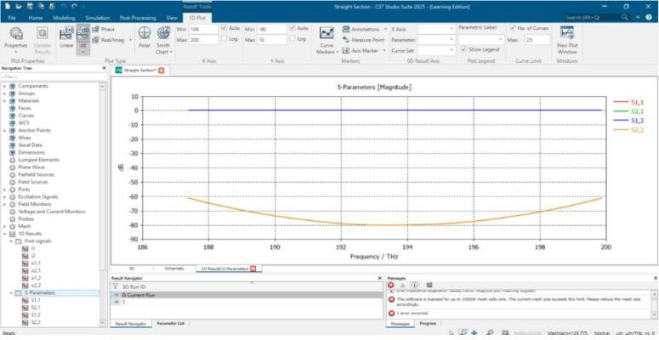

RESULT:
The rectangular to circular waveguide transition was successfully simulated using CST Studio Suite. The
electric field distribution at Port 2 was observed and analyzed, showing the expected spatial variation and
field intensity profile across the port region. The magnetic field distribution at Port 2 was also obtained,
indicating the corresponding magnetic field patterns consistent with electromagnetic wave propagation.
The electric and magnetic field parameters at Port 2 were successfully measured and recorded.
The electric and magnetic field parameters at Port 2 were successfully measured and recorded.

